**Smart Health Disease Prediction**

Submitted in partial fulfillment of the requirements for the award of degree of

**BACHELOR OF ENGINEERING**

**IN**

**COMPUTER SCIENCE & ENGINEERING**



**Submitted to:**

**Prof. Arshleen**

**Submitted By:**

SHOBHIT ARYAN LAL 18BCS1099

HIMANSHU DUBEY 18BCS1160

**DEPARTMENT OF COMPUTER SCIENCE & ENGINEERING**

**Chandigarh University, Gharuan**

**August 2020**

**PROJECT DESIGN**

Disease Predictor is the ability to predict the disease that has been provided to the system. For disease prediction, we need to implement the naïve Byes Classifier :

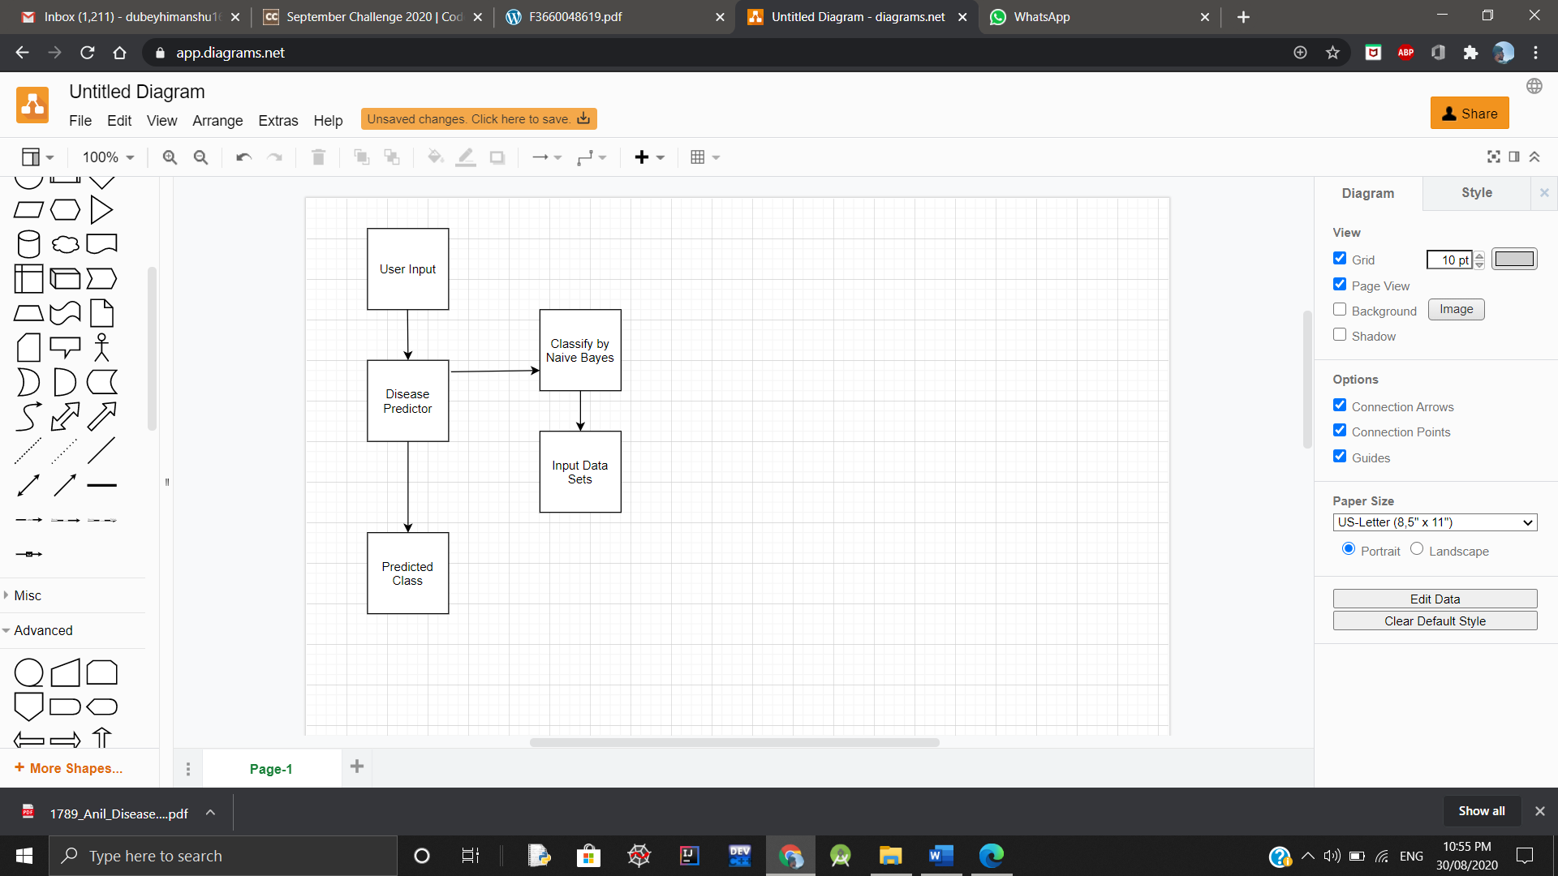

**CONSTRAINTS**

User gives input to the system. The input consists of symptoms. The user marks the symptoms due to which the user is feeling unwell.

1. Fever

2. Cough

3. Vomiting

Sample Datasets are :

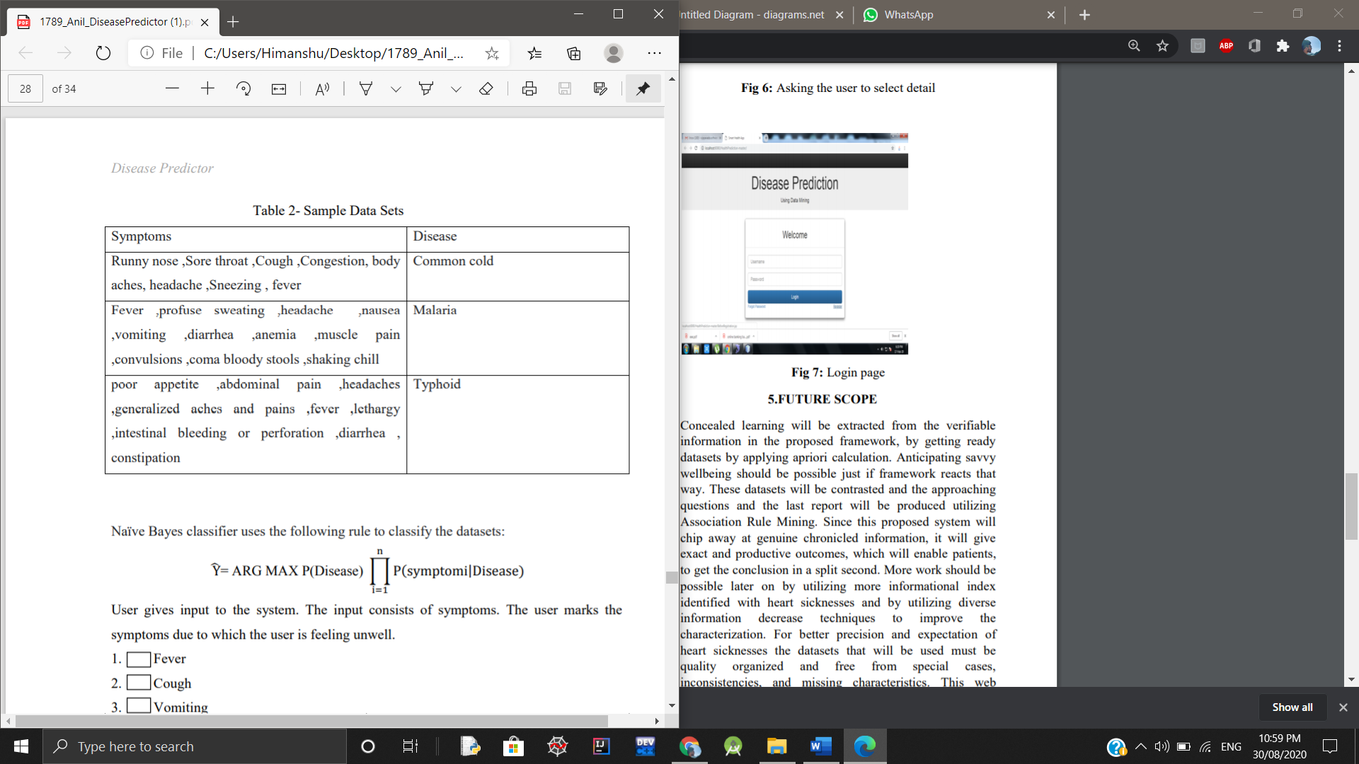

The “Disease Predictor” system predicts the disease according to the input data sets and calculates the probability of the disease. The **sample output** is given as:

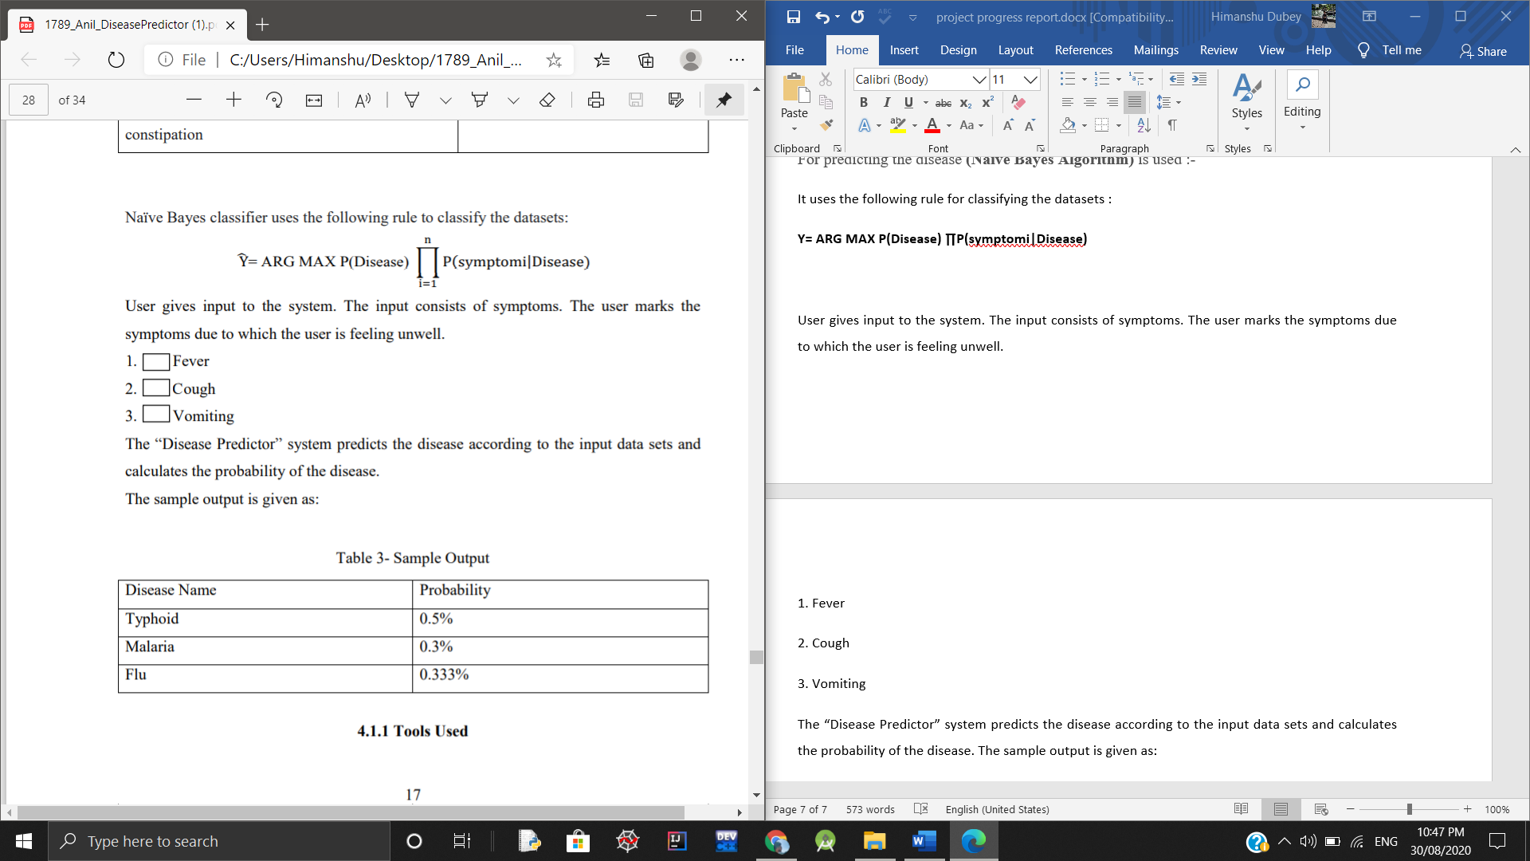

**Prediction of Disease by Naïve Bayes Algo :-**

The major classes in the application are:

**Symptoms Reader**

This class is the run first when the user wants for disease prediction

Input: User selects the symptoms from the list.

Output: The selected symptoms are put in the list

**Symptoms Analyzer**

Input: Takes the user input i.e. symptoms.

Output: Predicts the disease

**Calculate Values**

Here the actual mathematical computation takes place

**Description :**

**Module 1: (Patient Module)**

**Patient login:**

Patient login to the framework using ID and password

**Patient registration:**

If a patient is a new client, the framework asks for personal details by giving client ID and secret key through which he can login to the framework

**Prediction of the disease:**

The patient will show the side effects caused as a result of his ailment. The system will make certain request with respect to his ailment and after that anticipate the disease depending on the indications determined by patient and the framework will likewise propose specialists dependent on the illness.

**Inquiry about Doctor:**

Patient can scan for specialist by indicating name, address or type.

**Remark:**

Input: Patient will comment his view and this will be accounted to the administrator.

**Module 2: ( Doctor Module )**

**Specialist Login:**

Doctor will get to the framework utilizing his User ID and Password.

**Details of the patient:**

Specialist can view the details of the patient that are given by the patient at the time of registration.

**Notification:**

Doctor will get notice on what number of individuals had gotten to the framework and what all are the symptoms anticipated by the framework.

**UML DIAGRAMS REPRESENTING IMPLEMENTATION :-**

1. **ER DIAGRAM:-**
2. **SEQUENCE DIAGRAM :- (Patient Module)**

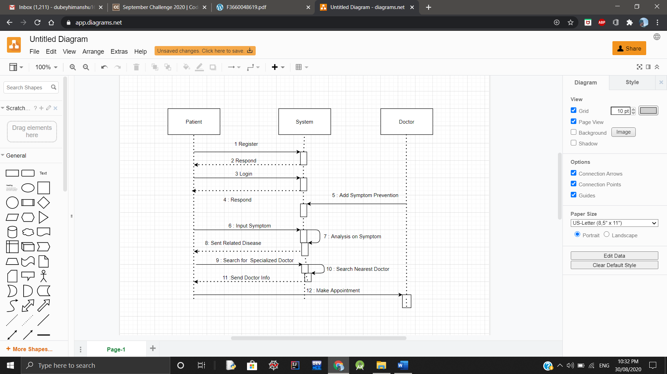

**Working :-**

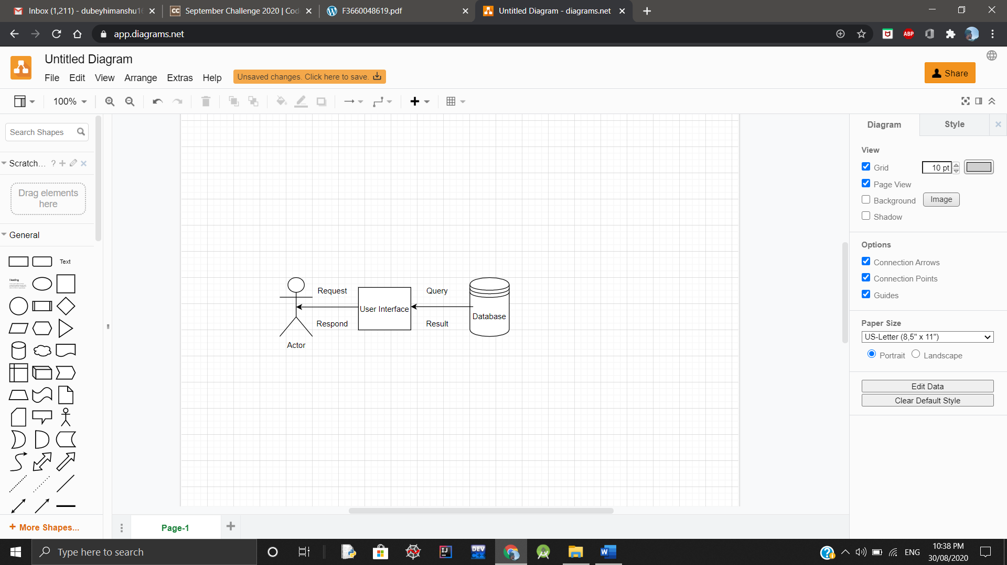

1. **CLASS DIAGRAM :-**

**Algorithm Used:- (Naïve Bayes Algorithm)**

For predicting the disease Naïve Bayes Algorithm is used :-

It uses the following rule for classifying the datasets :

**Y= ARG MAX P(Disease) ∏P(Symptom|Disease)**

Following advances are actualized in Bayes calculation:-

Bayes’ Theorem :

**P(c | x) = P ( x | c) P(c) / P (x)**

Where,

P (c | x) = Posterior Probability

P (c) = Prior probability

P (x | c) = probability of predictor

P(x) = Predictor’s prior probability

**Tools used :-**

1. HTML is used to display content in the browser.

2. CSS is used to properly align the HTML content.

3. Grails framework is used for developing the application.

4. Creately is used for constructing figures.